**Experiment 19:** Demonstrate Infrastructure as a Service (IaaS) by creating a Virtual Machine using a Public Cloud Service Provider (Azure), configure with required memory and CPU.

Step 1: Search for Virtual Machine in Search bar.

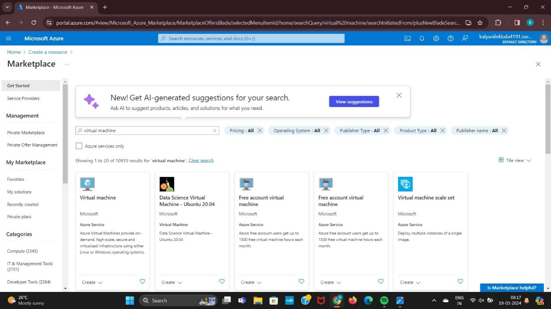

Step 2: Click On Create Option.

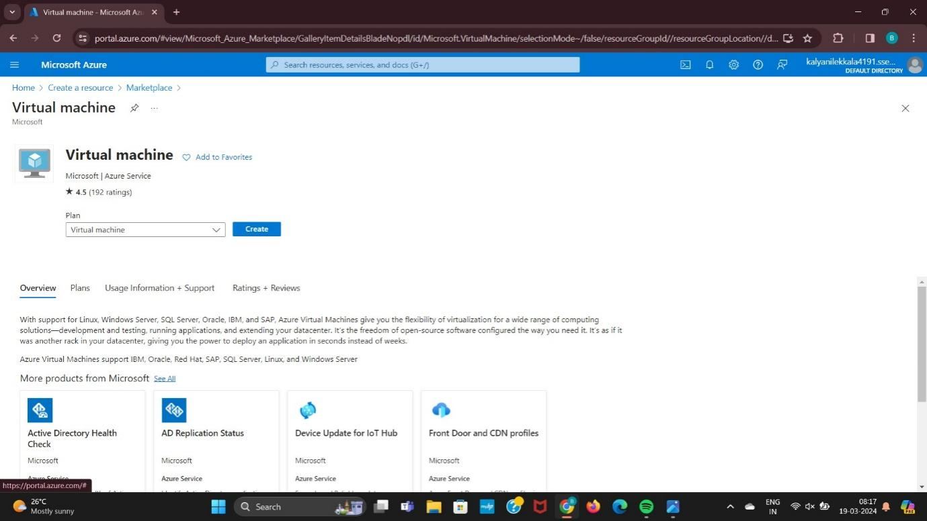

Step 3: Enter the Resource group and Instance details.

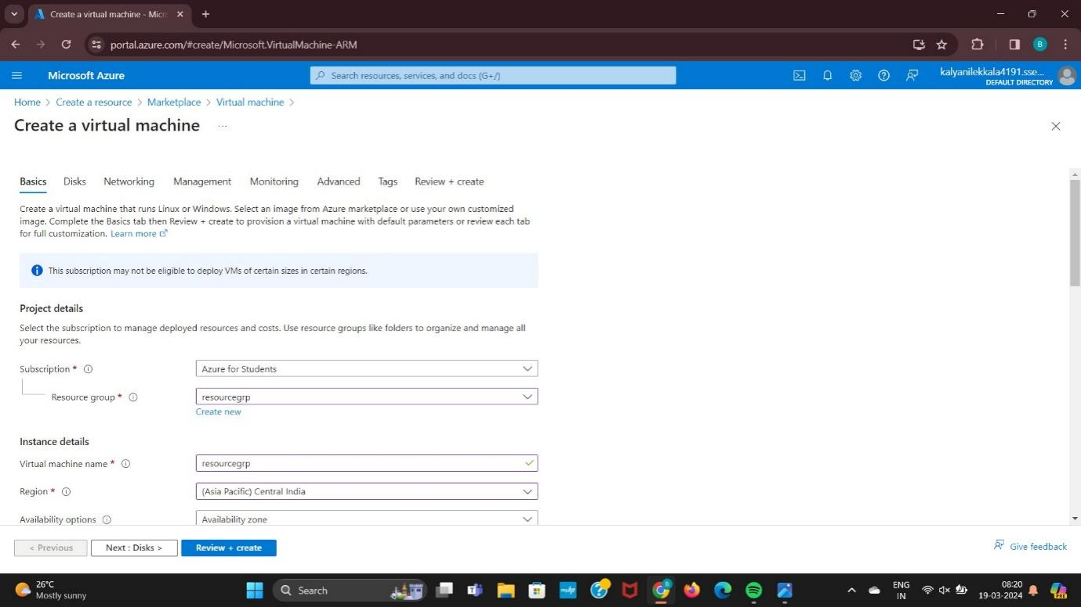

Step 4: Enter the Details of the Networking.

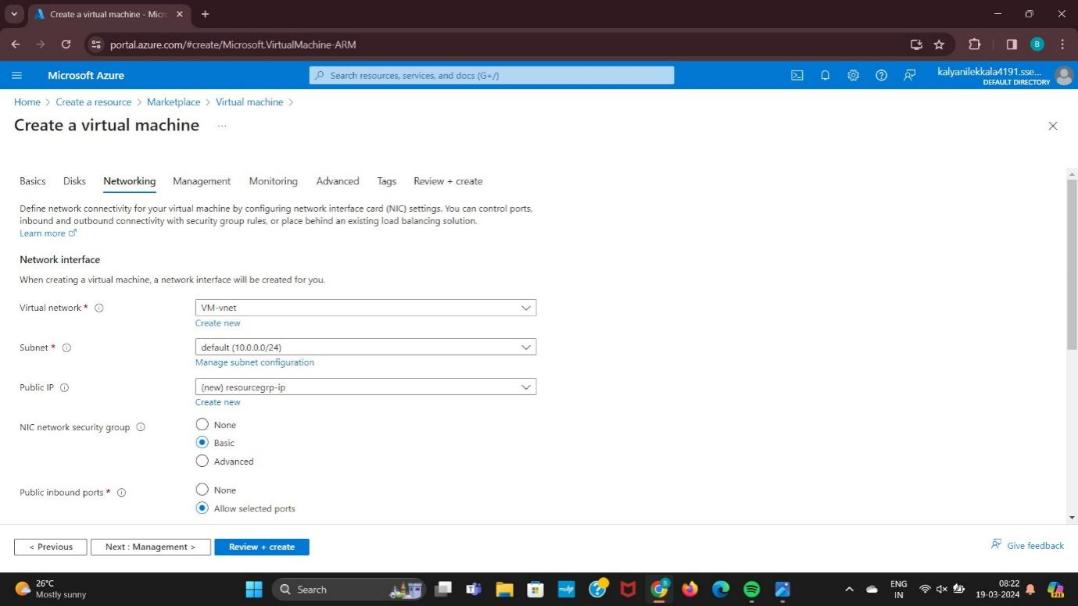

Step 5: Enter the Details of the Management.

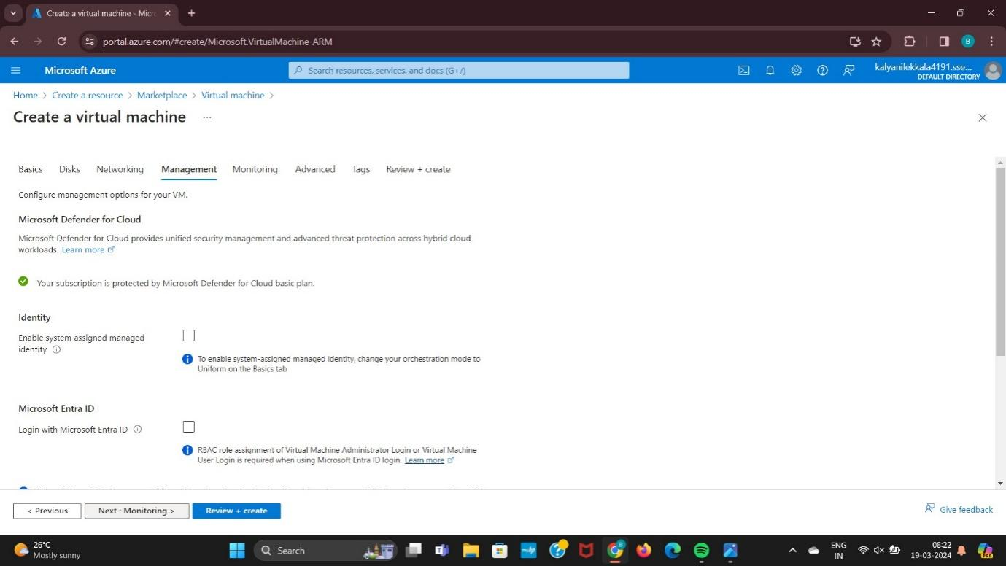

Step 6: Enter the Details Of the Monitoring.

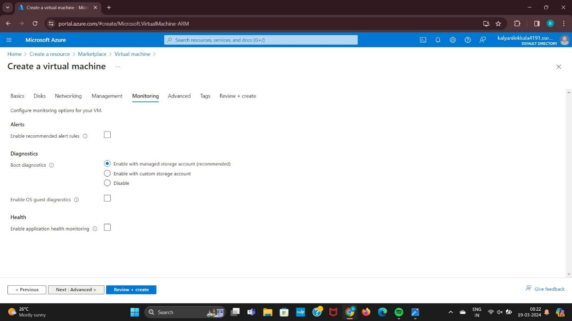

Step 7: Enter the Details Of the Advanced.

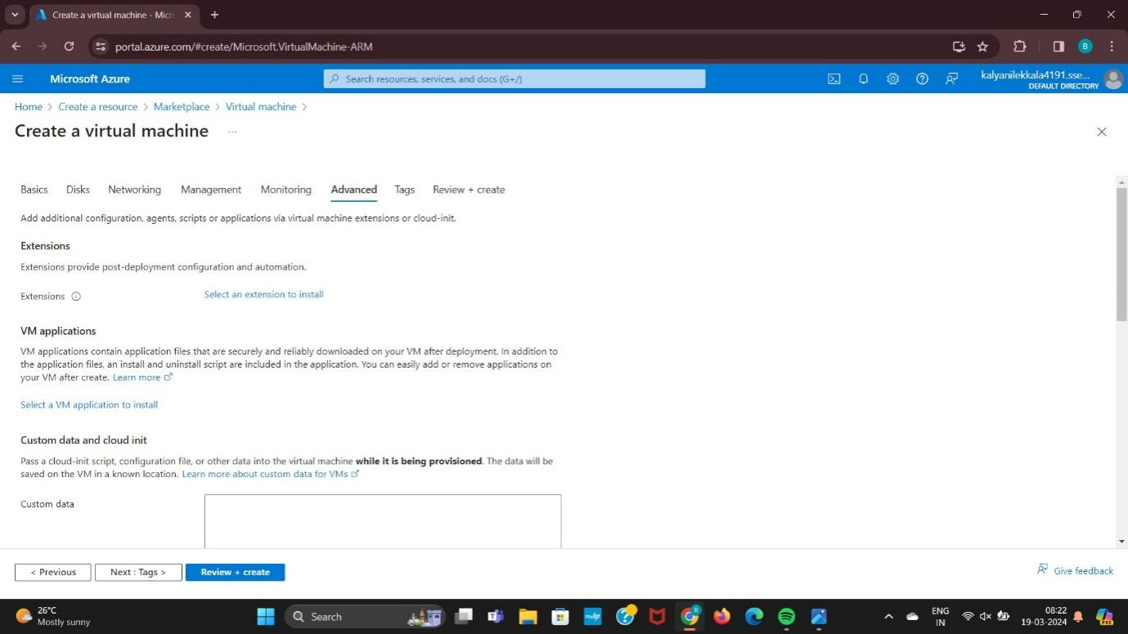

Step 8: Enter the Details of the Tags.

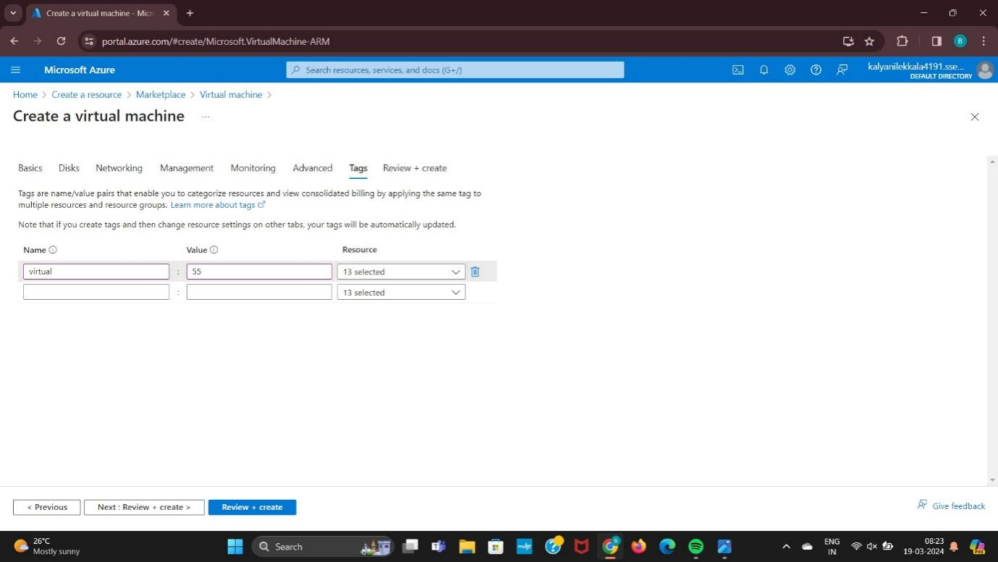

Step 9: Finally Validation Passed and Click on Create.

